**SPRINT DELIVERY – 3**

|  |  |
| --- | --- |
| **Team ID** | PNT2022TMID24187 |
| **Project Name** | Smart Farmer-IOT Enabled Smart Farming Application |
| **Date** | 17 November 2022 |

# Configuration of Node-Red to send commands to the IBM cloud

IBM IoT out node I used to send data from Node-Red to the IBM Watson device. So, after adding it to the flow we need to configure it with the credentials of our Watson device.

Here we add two buttons in UI

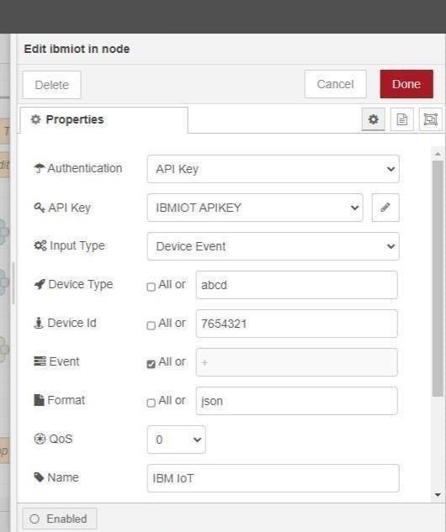

1. -> for motor on
2. -> for motor off

We used a function node to analyze the data received and assign commands to each number.

The Javascript code for the analyses is: if(msg.payload===1) msg.payload={"comm and”: “ON"}; else if(msg.payload===0) msg.

payload={"command”

: “OFF"};

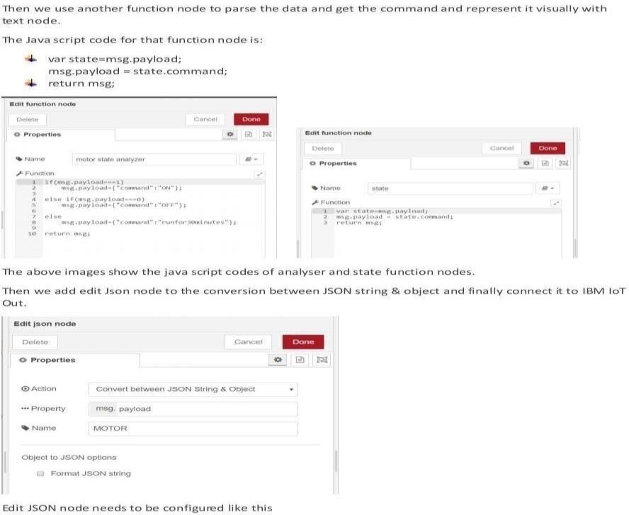

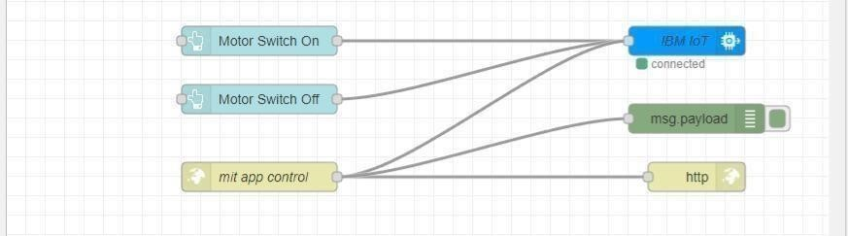

This is the program flow for sending commands to the IBM cloud.

# Adjusting User Interface

In order to display the parsed JSON data a Node-Red dashboard iscreated.

Here we are using Gauges, text, and button nodes to display in the UI and help to monitor the parameters and control the farm equipment. Below the images are the Gauge, text, and button node configurations.

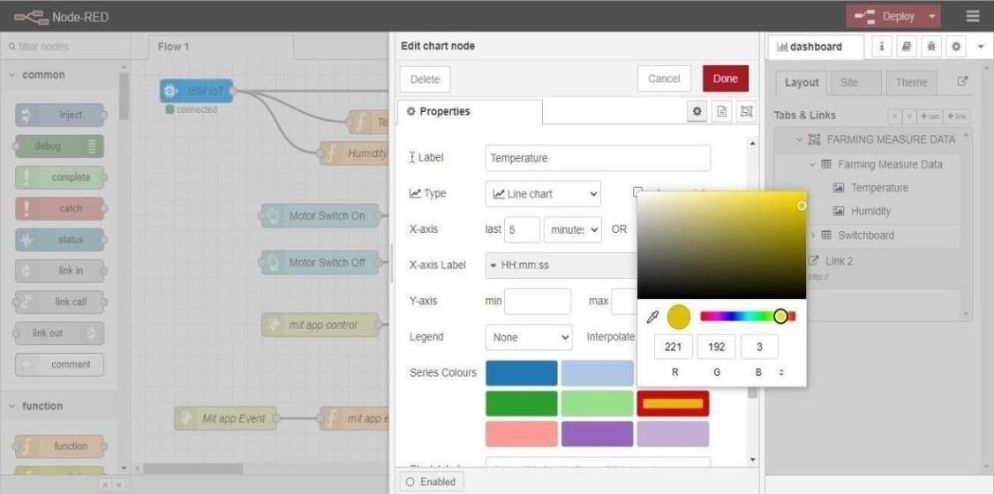

**Complete Program Flow**

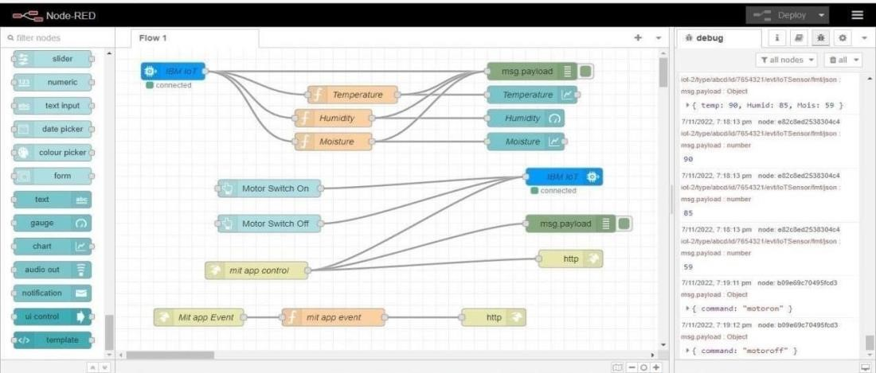

**MOBILE APP WEB:**

BLOCK DIAGRAM

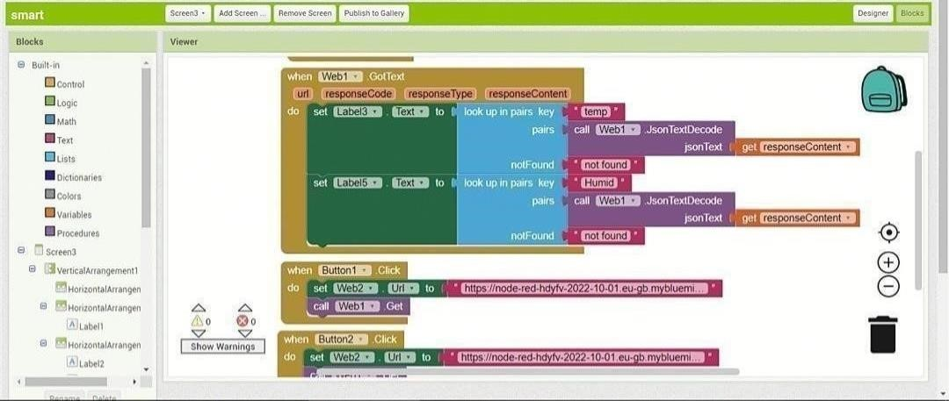

# SCREEN 1

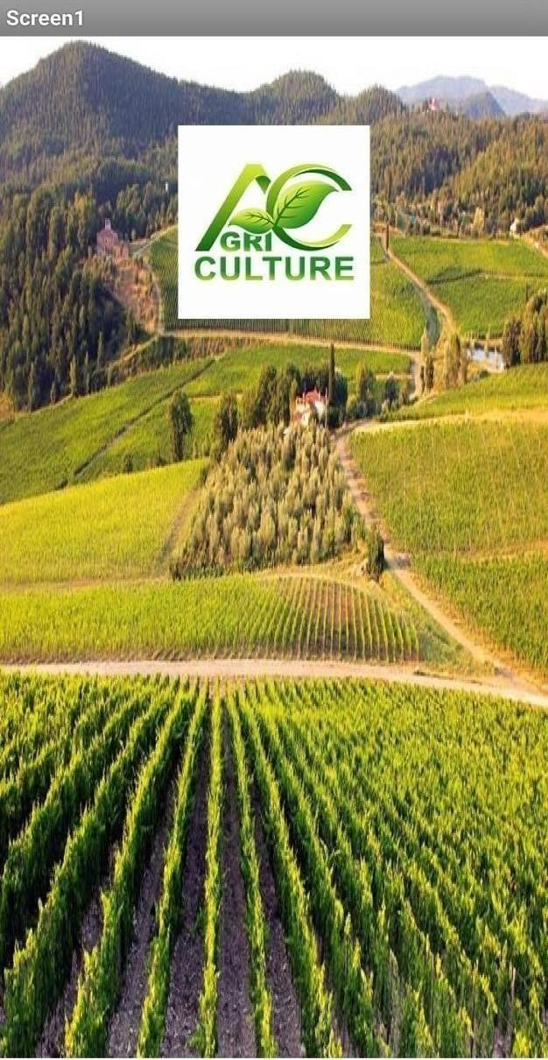

# SCREEN 2

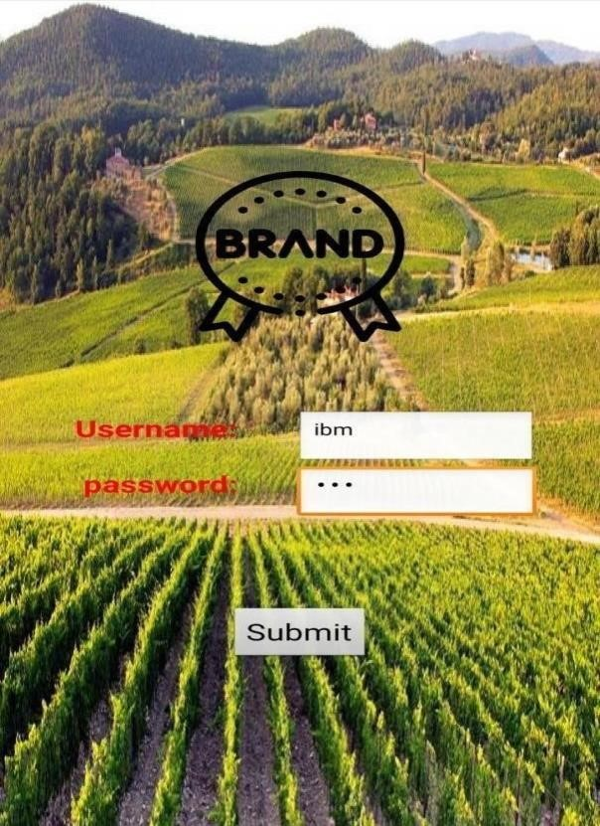

# SCREEN 3

Web APP UI Home Tab

